# HW 2 – Intelligent Control Theory

In this exercise we were tasked to compare the multicriteria fuzzy logic control from Homework 1, given different preferences regarding rise time, percentage overshoot and settling time, as well as evaluated by different measures. The preferences to compare were TR:%Os:TS = [1 : 10 : 2], [2 : 1 : 10] and [10 : 2 : 1] with first a plausibility measure (ξ = 0.9) and also a belief measure (ξ = 0.1).

## Comparing the measures

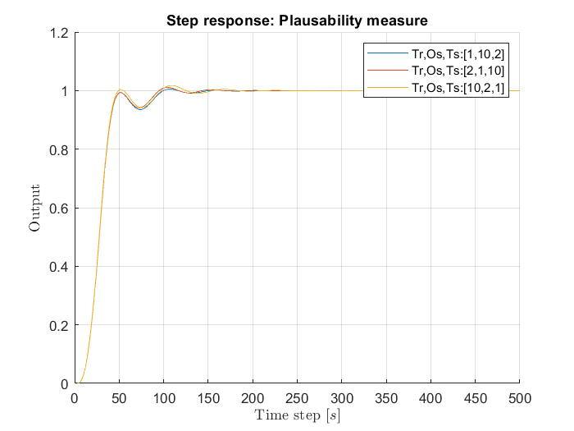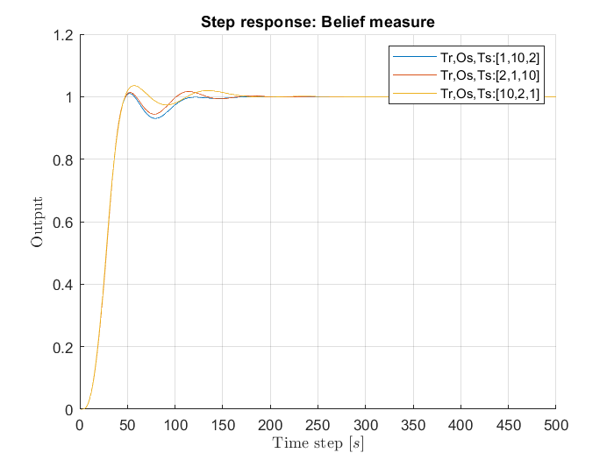

From a look at the different control responses one can see various effects from the different preferences and Fuzzy Measures.

## Plausibility measure vs Belief measure

The most significant difference between both Measures is, how far apart the different control responses are, depending on the control preference. The Plausibility Measure only appears to minorly change the response. If for example a short rise time is to be preferred a slightly stronger starting response can be observed. The Belief Measure instead reacts a lot stronger and will accept losses in terms of overshoot and settling time.

## Comparing the preferences

The goal of the preferences was to allow a different control response depending on a given weighted list of criteria. In the control response we can see this come to effect, especially if we take a look at the Belief Measure. By preferring a low overshoot percentage over a fast settling time over a fast rising time, the initial response is dampened and shows minimal overshoot.  
When a low settling time is preferred, the response allows small overshoot, but oscillations fade out quickly.  
Setting the focus on the rising time leads to a hard response with more overshoot and stronger oscillation.